Leon Truong, 2-2 Assignment, 11/1/2026

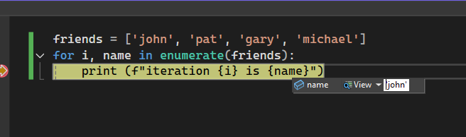
I stepped over twice
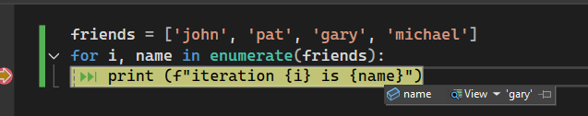
Friends is called incorrectly, and hovering over it should display the value in debug mode, but since it is not recognized, it does not


